**Exercise**

Q1.Write the following a functional interface and implement it using lambda:

1. To check whether the first number is greater than second number or not, Parameter (int ,int ) Return type boolean

2. Increment the number by 1 and return incremented value Parameter (int) Return int

3. Concatenation of 2 string Parameter (String , String ) Return (String)

4. Convert a string to uppercase and return . Parameter (String) Return (String)

Ans. - first write a functional interface(having only one abstract method) with method name its return type and parameters then make lambda function using interface name = its declaration and call the function using lambda.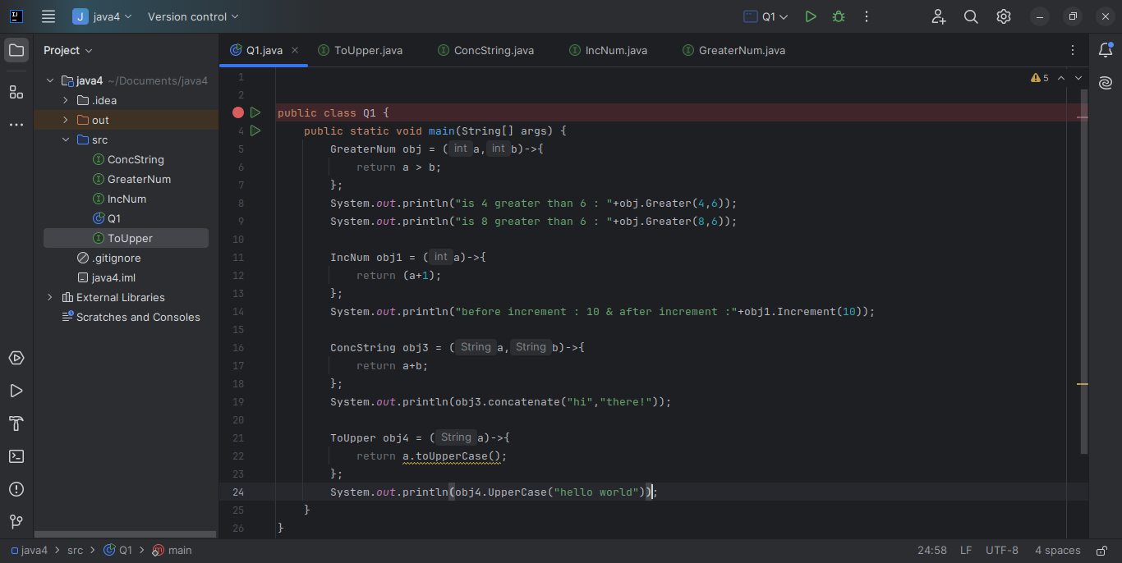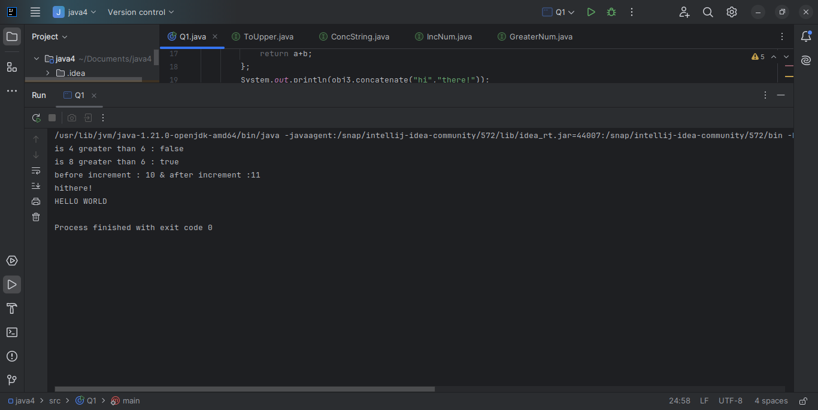

Q2. - Using (instance) Method reference create and apply add and subtract method and using (Static) Method reference create and apply multiplication method for the functional interface created

Ans. - Method reference is used to refer to any method that is already created and defined in any class to provide the implementation for functional interface’s abstract method. It can be done using instance methods as well as static methods.

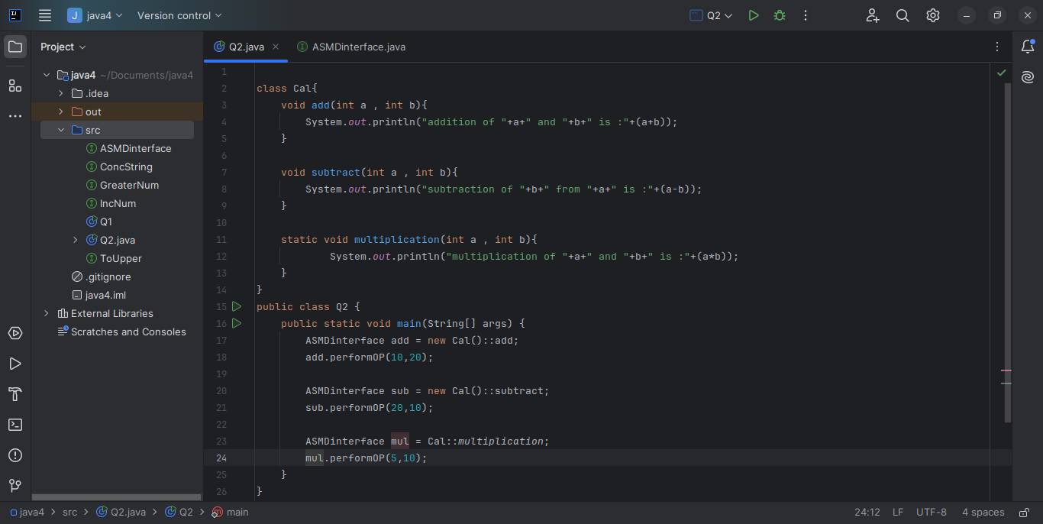

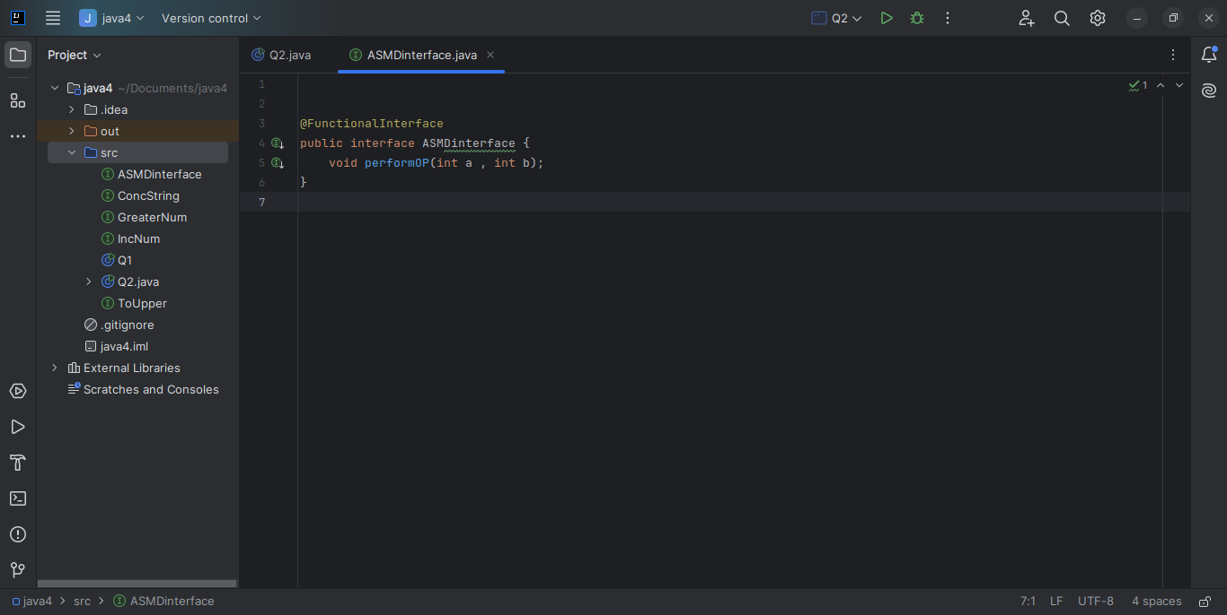

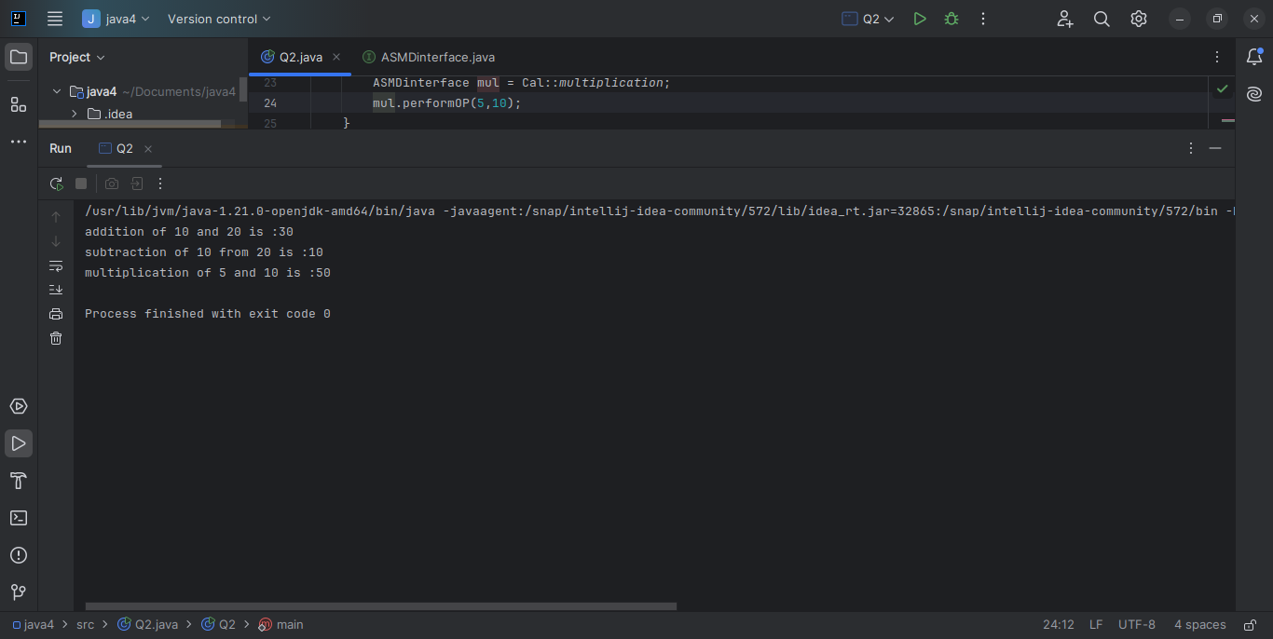

Q3. - Implement multiple inheritance with default method inside interface.

Ans. - multiple inheritance can be achieved by implementing multiple interface by a single class which contains some default methods and abstract methods. Default methods need not to be overridden by the class by abstract method must be overridden. We can call the default method of interface in subclass by super keyword without overridden.

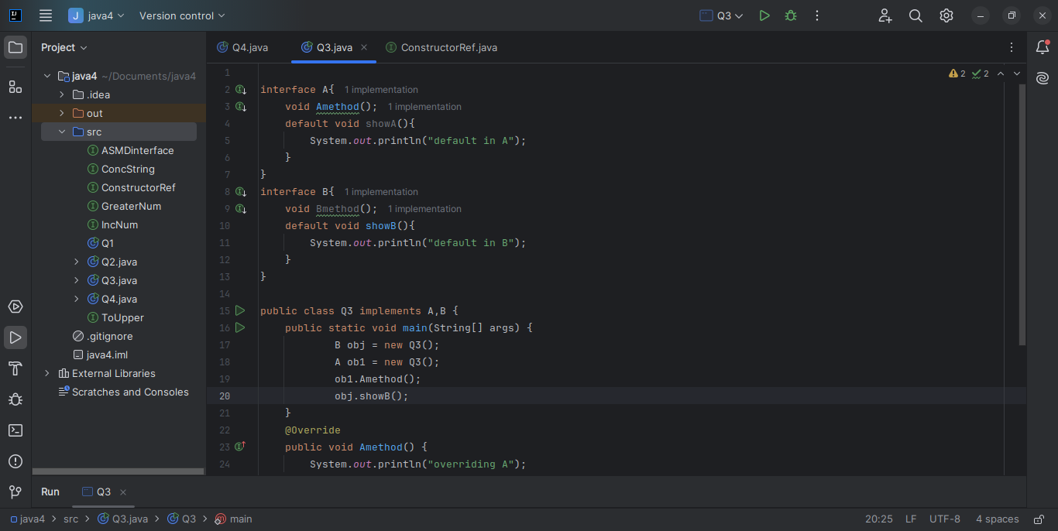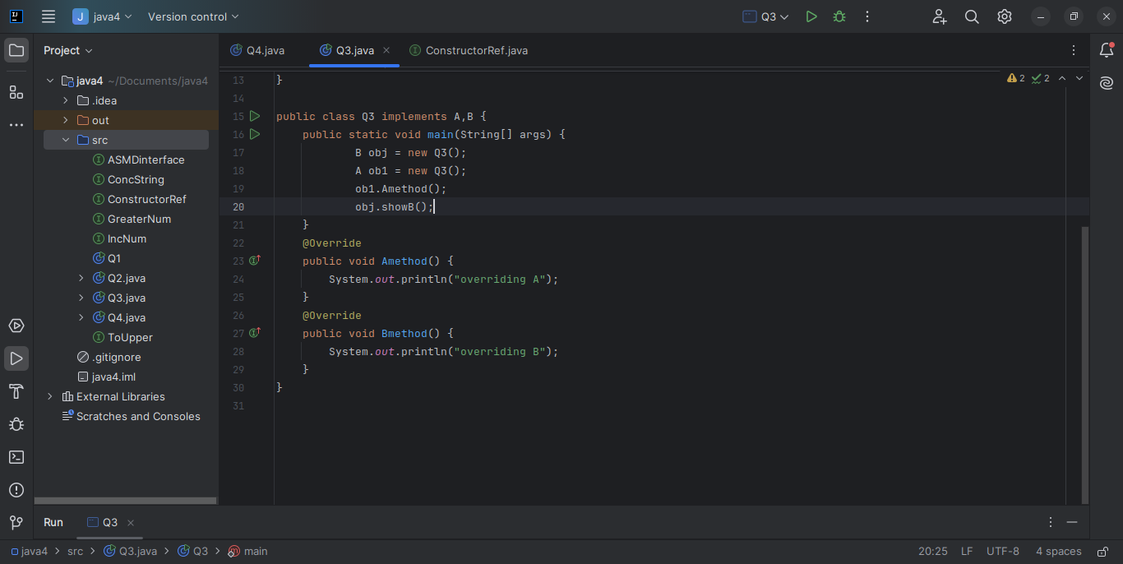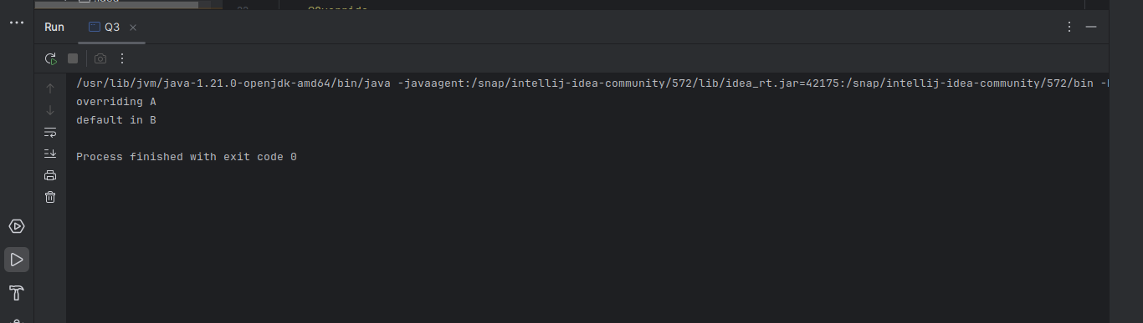

Q4. - Write a program to implement constructor reference

Ans. - we can also use a constructor of a class as a reference to be provided as implementation to our function in functional interface although the return type of method in interface is object of the class whose constructor is referenced by abstract method.

